Lab 11 – Data Structures with AI: Implementing Fundamental
Structures
Lab Objectives
• Use AI to assist in designing and implementing fundamental data
structures in Python.
• Learn how to prompt AI for structure creation, optimization, and
documentation.
• Improve understanding of Lists, Stacks, Queues, Linked Lists,
Trees, Graphs, and Hash Tables.
• Enhance code quality with AI-generated comments and
performance suggestions.
Task Description #1 – Stack Implementation
Task: Use AI to generate a Stack class with push, pop, peek, and is_empty
methods.
Sample Input Code:
class Stack:
pass
Expected Output:
• A functional stack implementation with all required methods and
docstrings.
PROMPT:
Use this prompt:
"Generate a Python `Stack` class using a list to store elements. Implement the methods `push()`, `pop()`, `peek()`, and `is_empty()`. Add clear docstrings for the class and every method. Handle popping or peeking from an empty stack appropriately. Include a short example demonstrating all four methods."

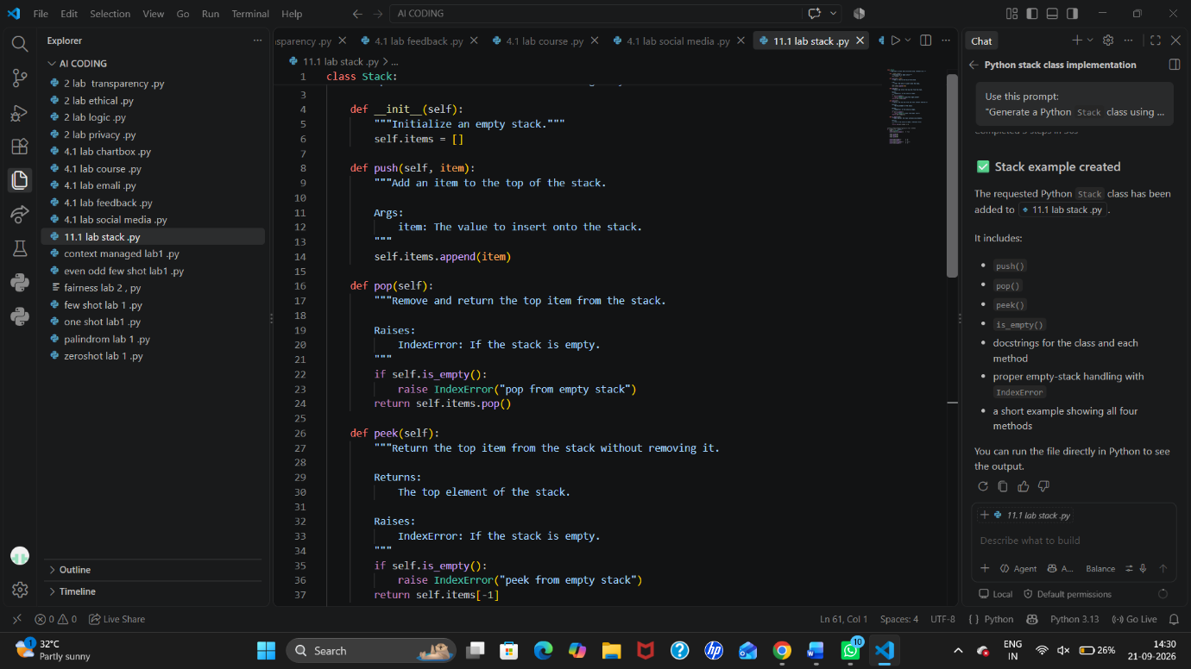
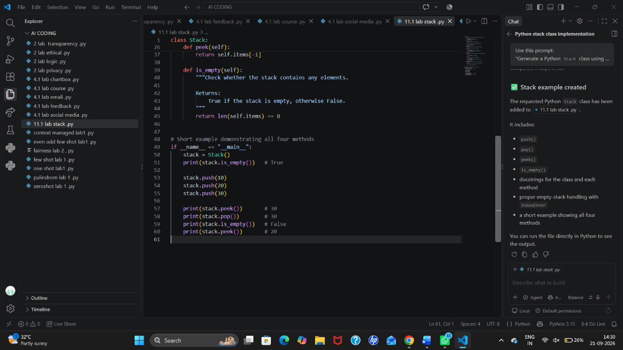
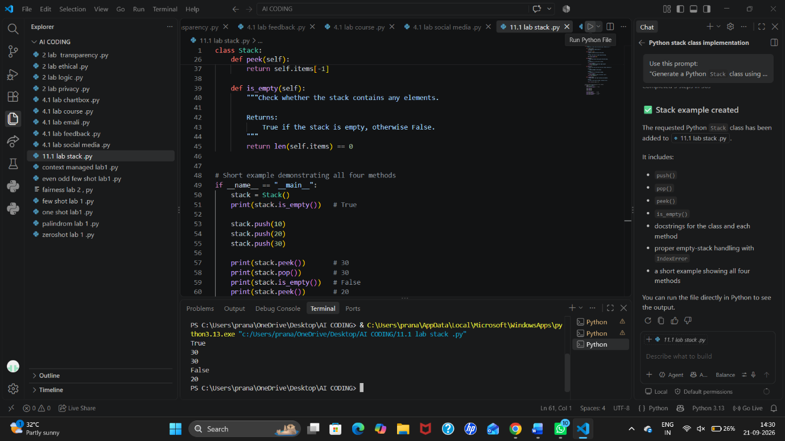
Task Description #2 – Queue Implementation
Task: Use AI to implement a Queue using Python lists.
Sample Input Code:
class Queue:
pass
Expected Output:
• FIFO-based queue class with enqueue, dequeue, peek, and size
methods.
PROMPT:
"Write a Python program to implement a Queue class using a list following the FIFO (First-In, First-Out) principle. Include `__init__()`, `enqueue()`, `dequeue()`, `peek()`, `size()`, and `is_empty()` methods with docstrings. Handle empty-queue cases and demonstrate the queue by adding 10, 20, and 30, then display the queue, front element, removed element, and queue size."

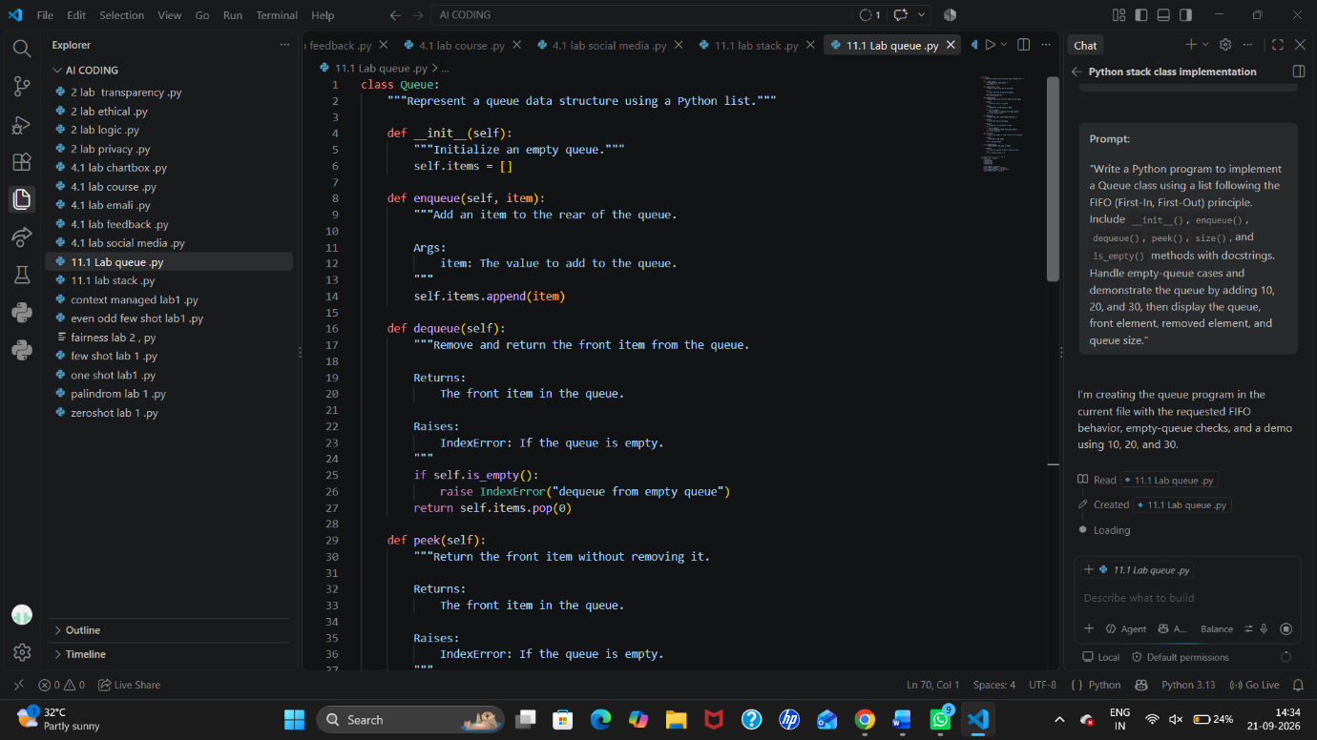
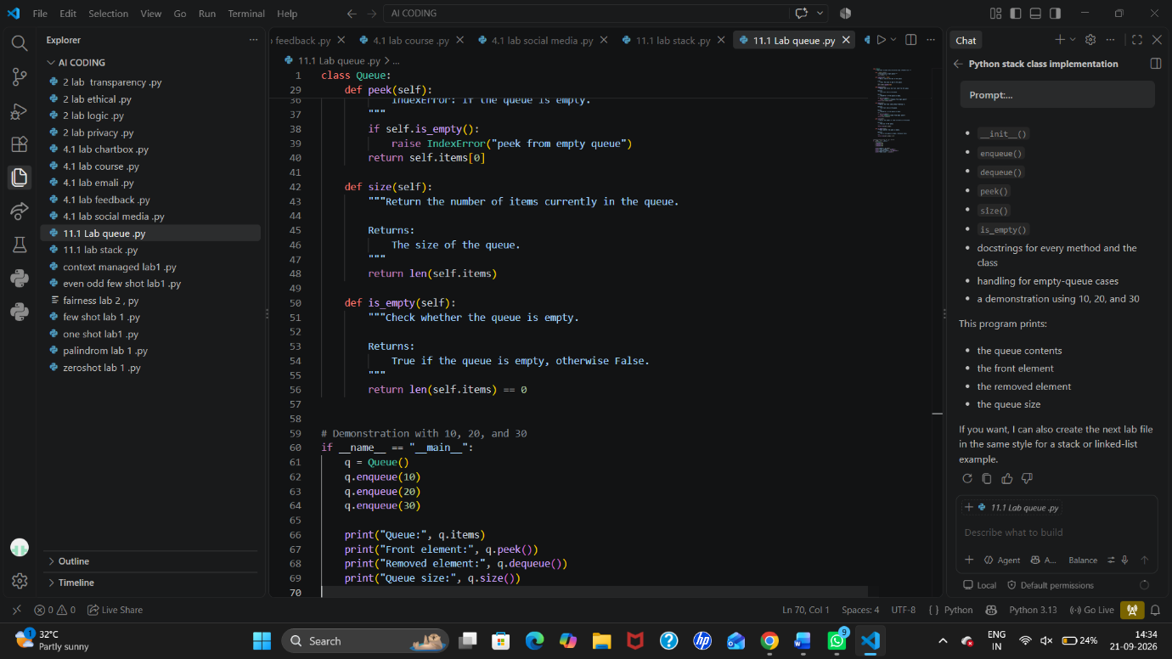

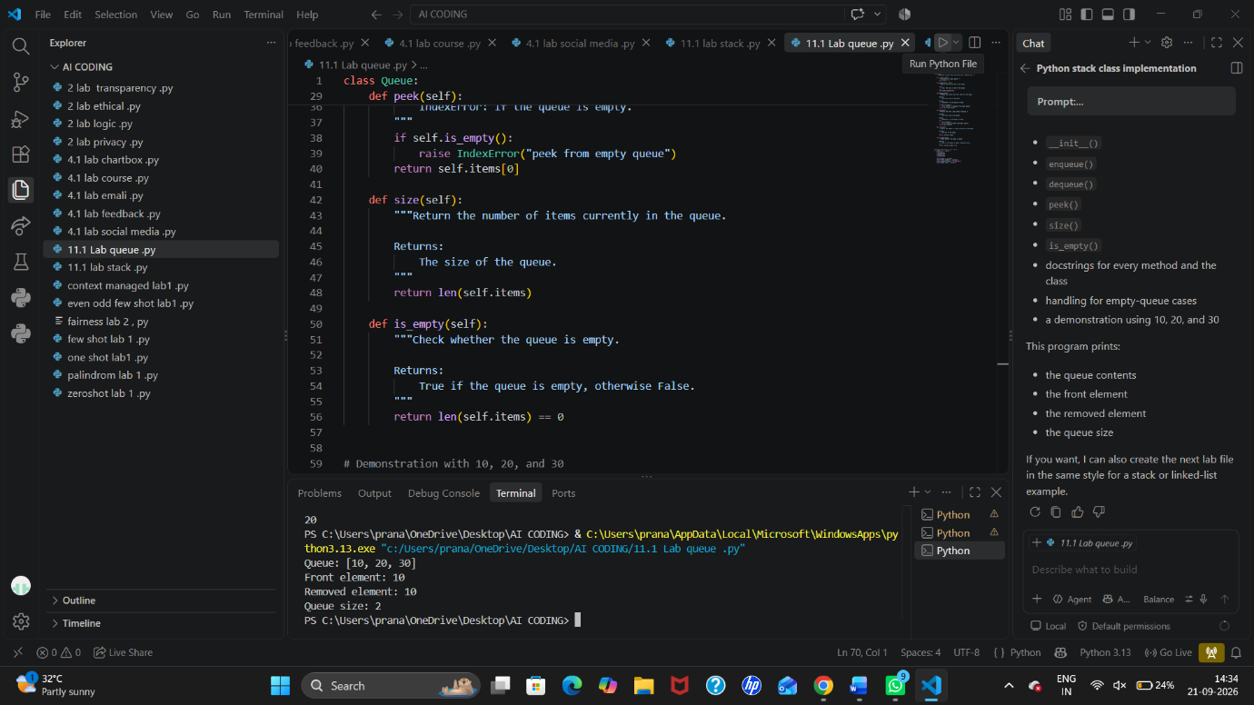
Task Description #3 – Linked List
Task: Use AI to generate a Singly Linked List with insert and display
methods.
Sample Input Code:
class Node:
pass

Week6 -
Monday

class LinkedList:
pass
Expected Output:
• A working linked list implementation with clear method
documentation.
PROMPT:
"Generate a Python program to implement a Singly Linked List using two classes: `Node` and `LinkedList`. The `Node` class should store data and a reference to the next node. The `LinkedList` class should include `insert()` and `display()` methods. Add clear docstrings and comments explaining the code. Include an example that inserts a few elements and displays the linked list."
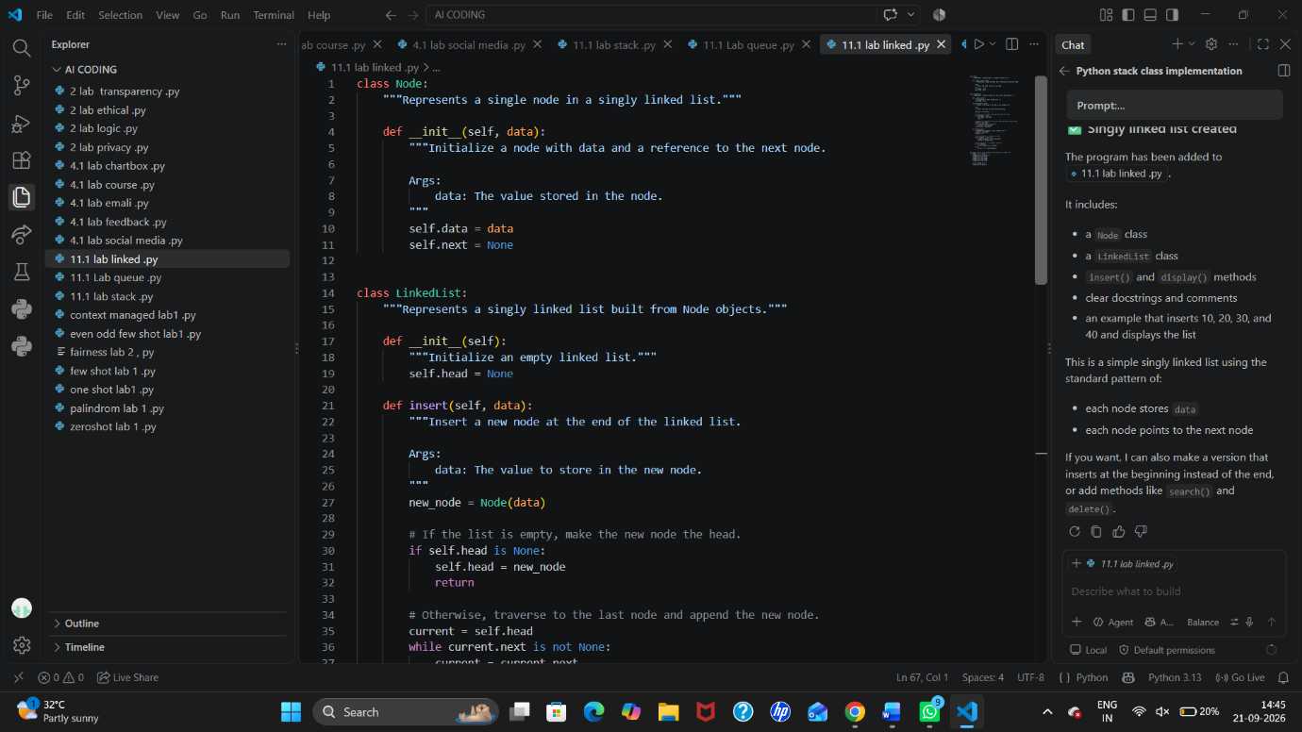
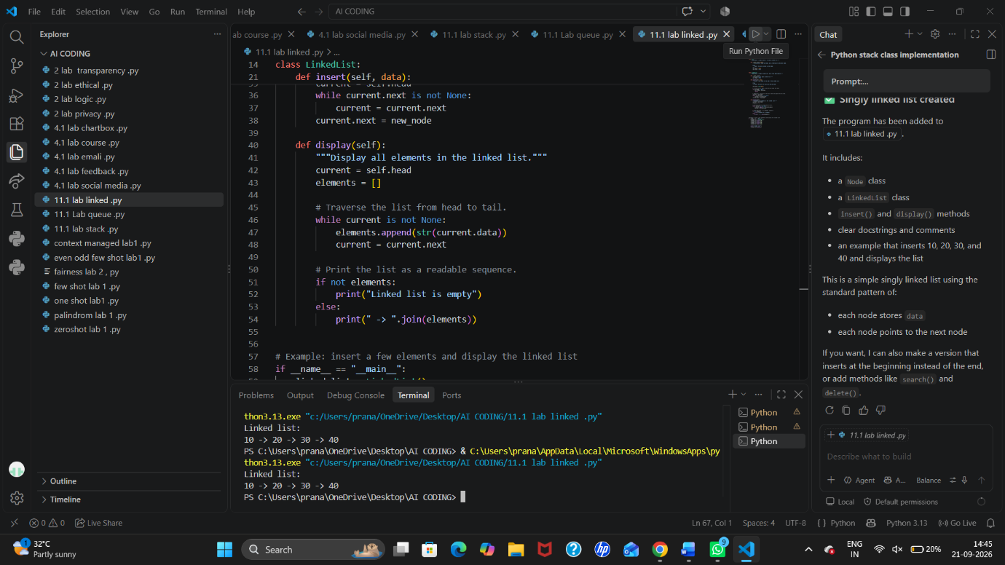
Task Description #4 – Binary Search Tree (BST)
Task: Use AI to create a BST with insert and in-order traversal methods.
Sample Input Code:
class BST:
pass
Expected Output:
• BST implementation with recursive insert and traversal methods.
PROMT:
"Generate a Python program to implement a Binary Search Tree (BST) using a `BST` class. Include a recursive `insert()` method to add elements and a recursive `inorder()` traversal method to display the elements in sorted order. Handle the root node properly and include clear comments/docstrings. Provide a short example demonstrating insertion and in-order traversal."

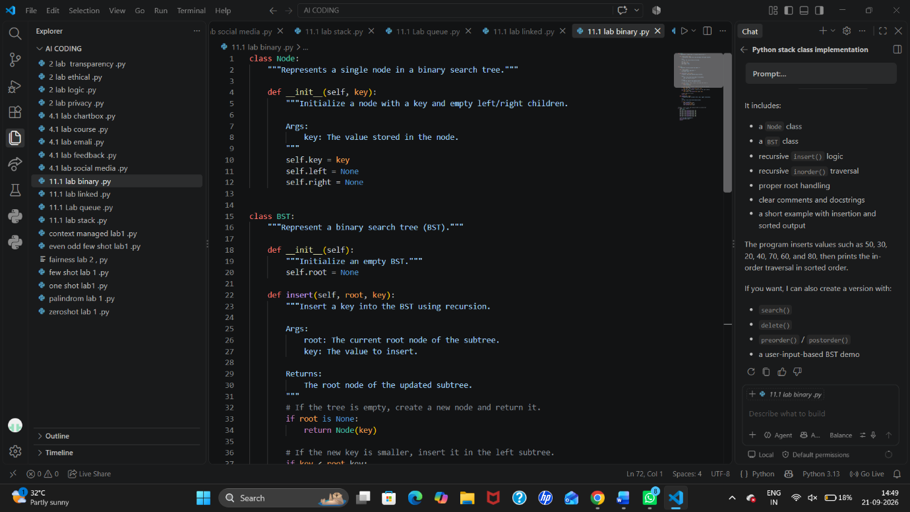
i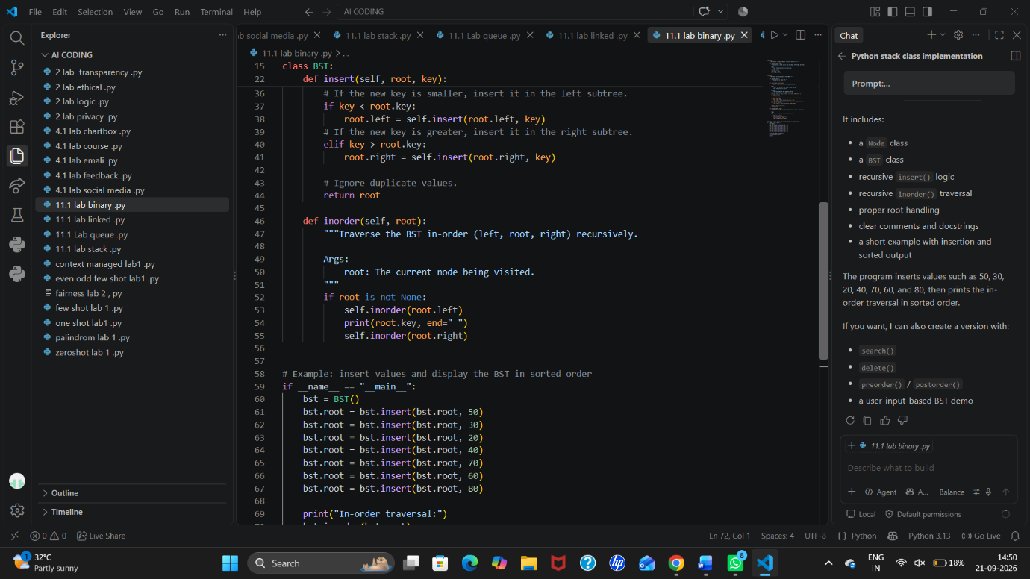
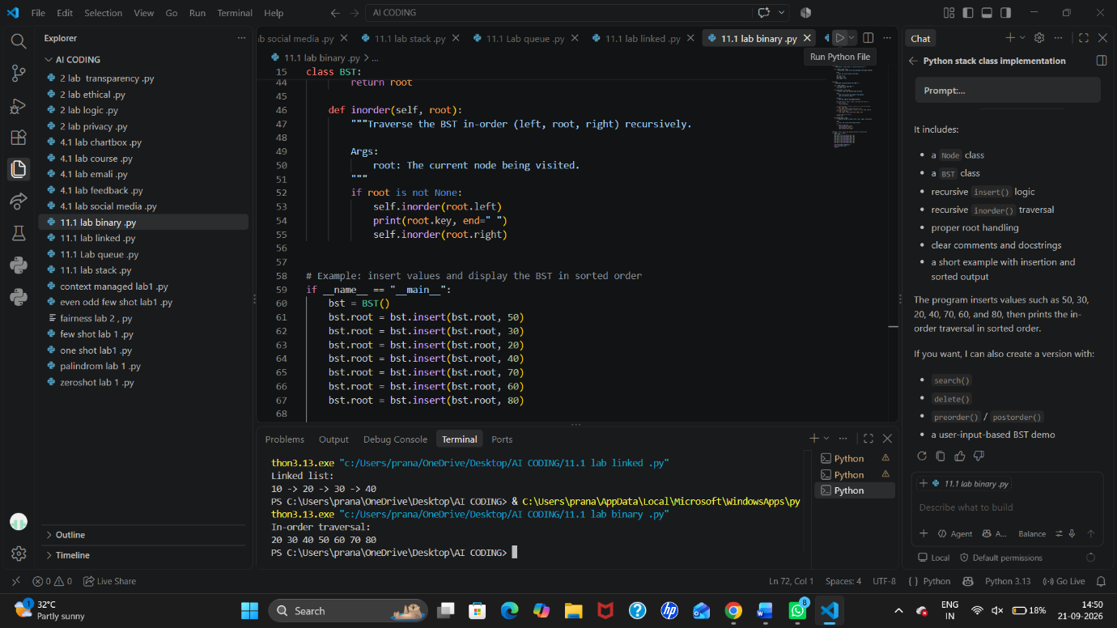
Task Description #5 – Priority Queue
Task: Use AI to implement a priority queue using Python’s heapq
module.
Sample Input Code:
class PriorityQueue:
pass
Expected Output:
• Implementation with enqueue (priority), dequeue (highest priority),
and display methods.
PROMPT:
Implement a Python Priority Queue using `heapq` with `enqueue(priority)`, `dequeue()` for the highest-priority item, and `display()` methods. Use the starter class `PriorityQueue: pass`. Include simple comments, method documentation, and sample input/output.

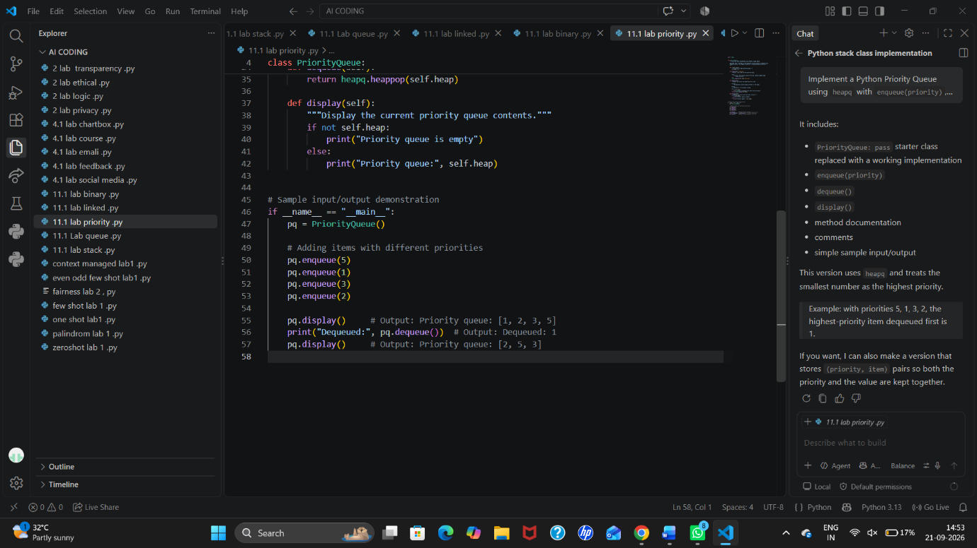
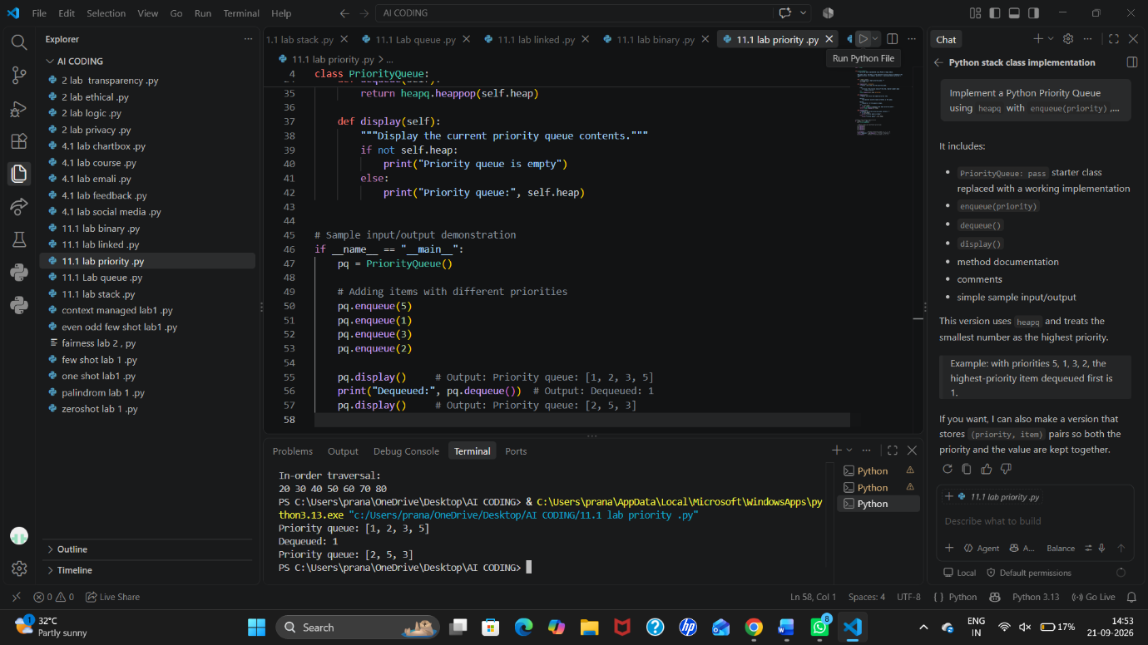
Task Description #6 – Deque
Task: Use AI to implement a double-ended queue using
collections.deque.
Sample Input Code:
class DequeDS:
pass

Expected Output:
• Insert and remove from both ends with docstrings.
Prompt:
Implement a Python Deque using `collections.deque` with methods to insert and remove elements from both ends. Use the starter class `DequeDS: pass`. Include simple docstrings, comments, and sample input/output.
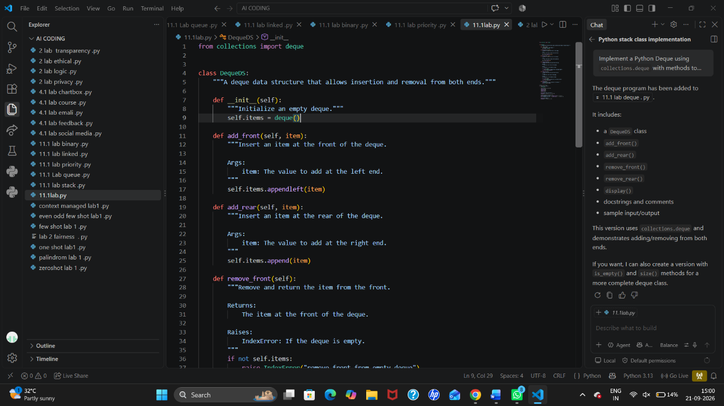
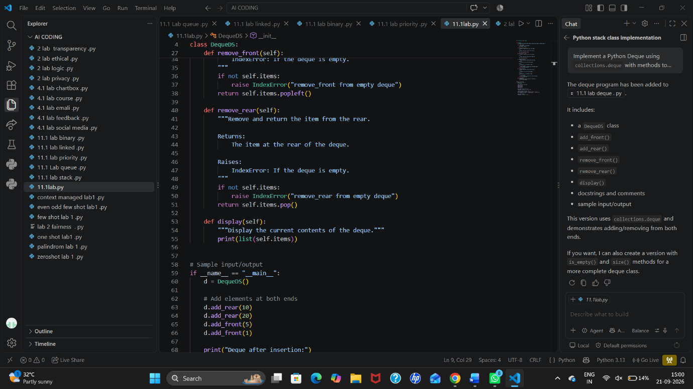
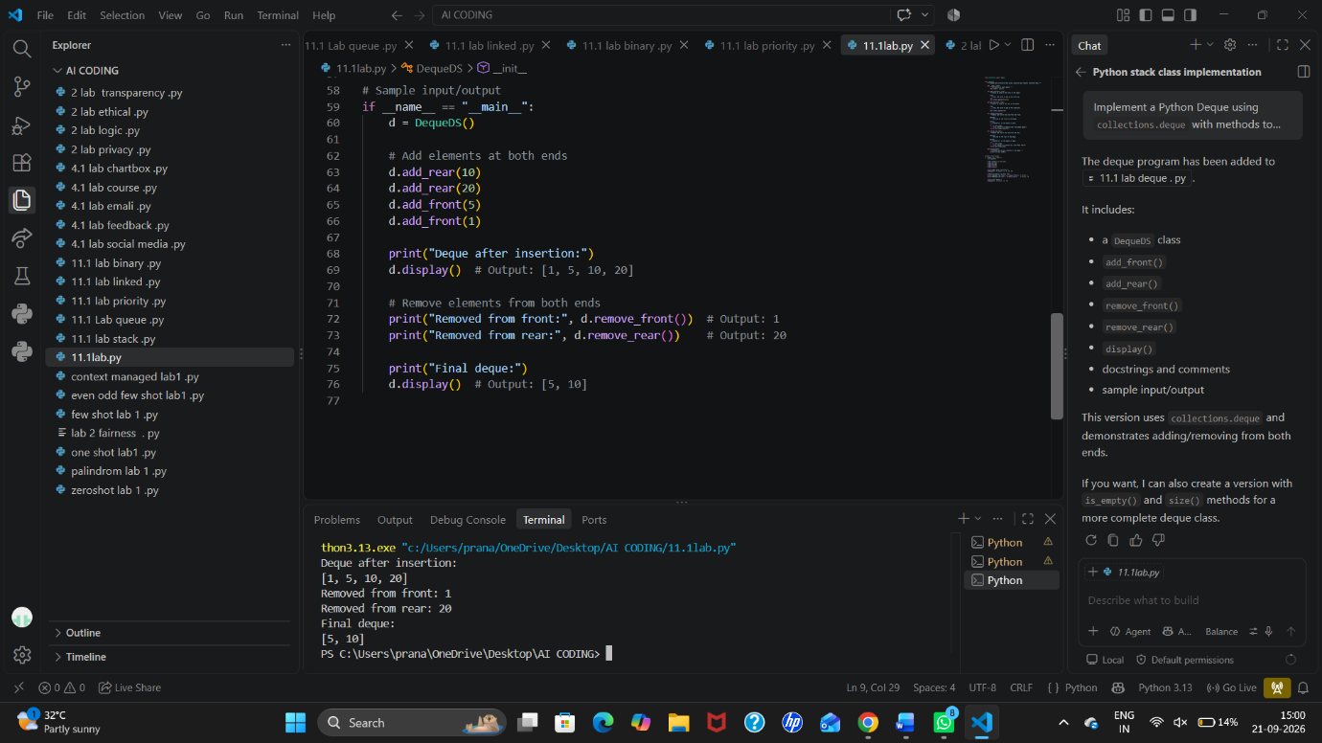
Task Description #7 Real-Time Application Challenge – Choose the
Right Data Structure
Scenario:
Your college wants to develop a Campus Resource Management System
that handles:
1. Student Attendance Tracking – Daily log of students
entering/exiting the campus.
2. Event Registration System – Manage participants in events with
quick search and removal.
3. Library Book Borrowing – Keep track of available books and their
due dates.

4. Bus Scheduling System – Maintain bus routes and stop
connections.
5. Cafeteria Order Queue – Serve students in the order they arrive.
Student Task:
• For each feature, select the most appropriate data structure from
the list below:
o Stack
o Queue
o Priority Queue
o Linked List
o Binary Search Tree (BST)
o Graph
o Hash Table
o Deque
• Justify your choice in 2–3 sentences per feature.
• Implement one selected feature as a working Python program with
AI-assisted code generation.
Expected Output:
• A table mapping feature → chosen data structure → justification.
• A functional Python program implementing the chosen feature
with comments and docstrings.
PROMPT:
"Create a complete solution for a Campus Resource Management System. For each of these features—Student Attendance Tracking, Event Registration, Library Book Borrowing, Bus Scheduling, and Cafeteria Order Queue—select the most appropriate data structure from Stack, Queue, Priority Queue, Linked List, BST, Graph, Hash Table, and Deque. Provide a table with the feature, chosen data structure, and a 2–3 sentence justification. Then implement the Cafeteria Order Queue using Python's `collections.deque`, with clear comments, docstrings, and a working example that adds students, serves them in arrival order, and displays the remaining queue."
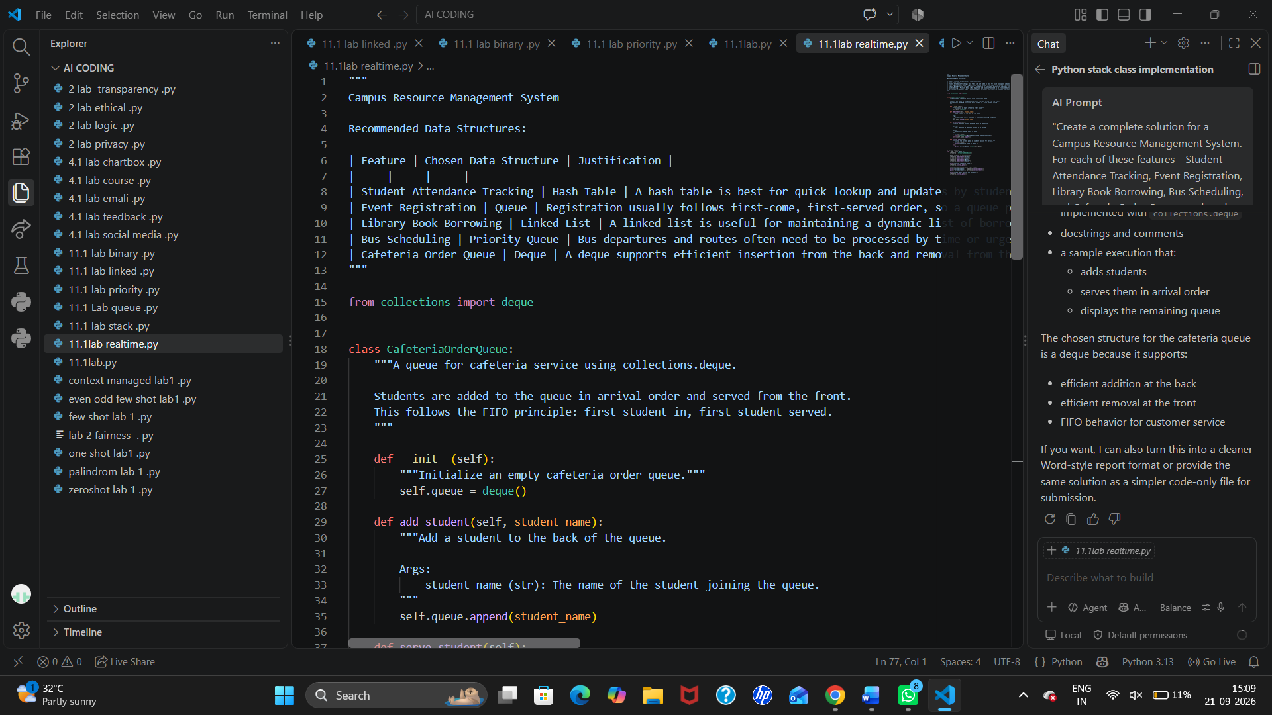

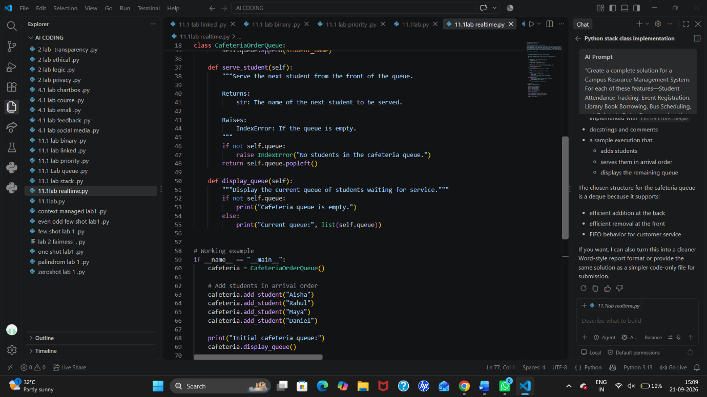
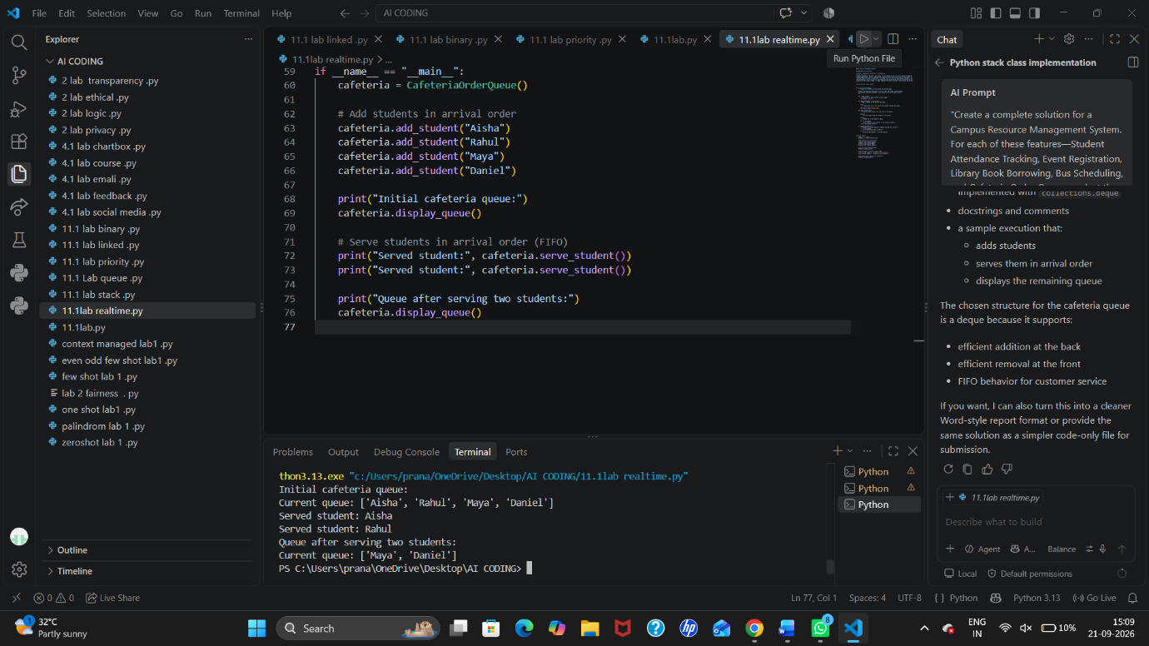
Task Description #8: Smart E-Commerce Platform – Data Structure
Challenge
An e-commerce company wants to build a Smart Online Shopping System
with:
1. Shopping Cart Management – Add and remove products
dynamically.
2. Order Processing System – Orders processed in the order they are
placed.
3. Top-Selling Products Tracker – Products ranked by sales count.

4. Product Search Engine – Fast lookup of products using product ID.
5. Delivery Route Planning – Connect warehouses and delivery
locations.
Student Task:
• For each feature, select the most appropriate data structure from
the list below:
o Stack
o Queue
o Priority Queue
o Linked List
o Binary Search Tree (BST)
o Deque
• Justify your choice in 2–3 sentences per feature.
• Implement one selected feature as a working Python program with
AI-assisted code generation.
Expected Output:
• A table mapping feature → chosen data structure → justification.
• A functional Python program implementing the chosen feature
with comments and docstrings.
PROMPT:
Use AI to select the most appropriate data structure for each e-commerce feature: Shopping Cart, Order Processing, Top-Selling Products, Product Search, and Delivery Route Planning. Use only Stack, Queue, Priority Queue, Linked List, BST, and Deque. Create a table with a 2–3 sentence justification for each choice, then implement one selected feature in Python with comments, docstrings, and working code.
